Extra Practice 7 Answers

1. a) As x increases by 1, y decreases by 6. The graph is a line that goes down to the right.
b) As x increases by 1, y increases by 5. The graph is a line that goes up to the right.

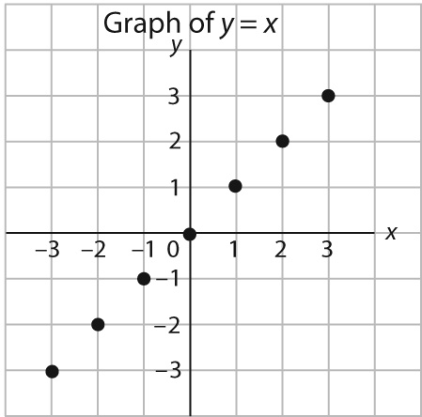
2. a)

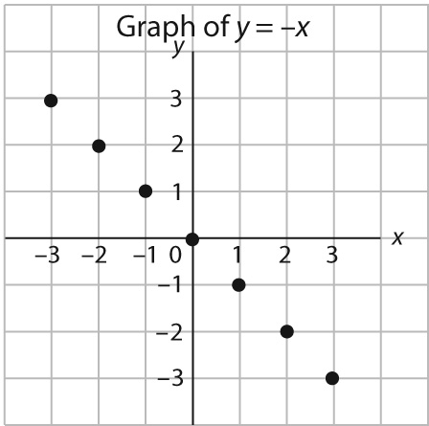
b)

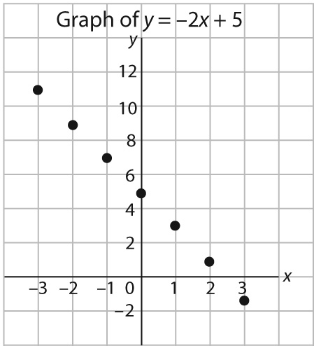
c)

d)
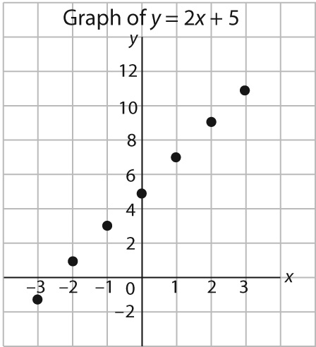

3. (–2, 12), (1, 6), (2, 4)
I used the patterns in the graph:
As x increases by 1, y decreases by 2.

4. a)
r | C
1 | 13
2 | 16
3 | 19
4 | 22
5 | 25
6 | 28

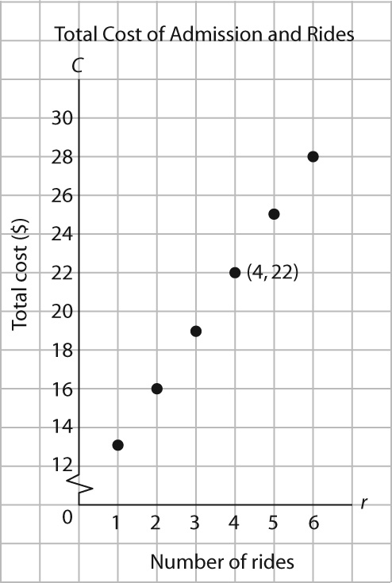
b)

c) As r increases by 1, C increases by 3. The graph is a line that goes up to the right.
d) (4, 22); Josh rode on 4 rides.

