**Properties of Angles in a Circle – Extra Practice**

**1.** Determine the measure of ∠ABC and ∠AEC. Explain how you determined your answers.

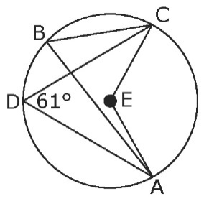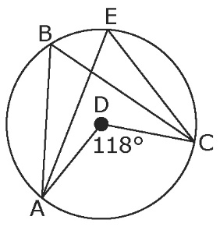**a)  b)**

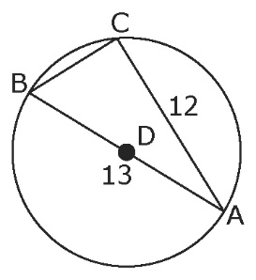**2.** Determine the length of chord BC in each of the following.

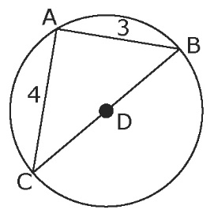**a)  b)**

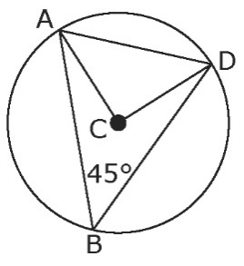**3.** Point C is the centre of a circular flower bed   
with a radius of 8 m. The flower bed is divided   
as shown in the diagram. If ∠ABD = 45°, determine   
the length of AD to the nearest tenth of a metre.

**4.** Find the unknown angle measure in each of the following diagrams.

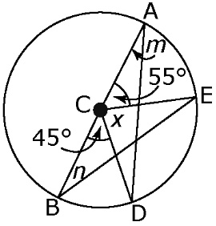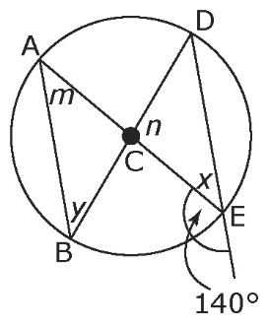**a)  b)**

∠*m* =

∠*n* =

∠*x* =

∠*m* =

∠*n* =

∠*x* =

∠*y* =

**Answers**

**1. a)** ∠ABC = ∠AEC = ∠ADC = 59°. Example: An inscribed angle is half the measure of a central angle subtended by the same arc.

**b)** ∠ABC = 61°, ∠AEC = 122°. Example: Inscribed angles subtended by the same arc of a circle are equal. A central angle is twice the measure of an inscribed angle subtended by the same arc.

**2. a)** BC = 5 units **b)** BC = 5 units

**3.** 11.3 m

**4. a)** *m* = 40°, *n* = 100°, *x* = 40°, *y* = 40°

**b)** *m* = 22.5°, *n* = 27.5°, *x* = 80°