Target A-1 Extra Practice

**1.** Identify the rational numbers.

**a)** 17  −3.606  –

**b)** –0.2    7.1234…

**2.** Write the opposite of each rational number.

**a)** 9 **b)**  **c)** –17.6

**d)**  **e)** 401 **f)** –7

**3.** Match each letter on the number line to one of the following rational numbers.

**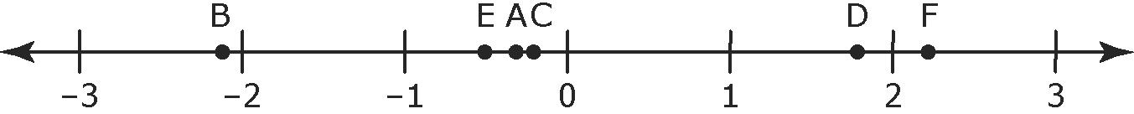**

 –0.3 

 –2.1 −

**4.** Compare , 1.7, –0.6, , and . Write the numbers in ascending order.

**5.** Compare –0.5, , , 1.9, and . Write the numbers in descending order.

**6.** Identify the equivalent fraction pairs.

**a)** ,  **b)** ,  **c)** , 

**7.** Identify the equivalent rational number pairs.

**a)** ,  **b)** ,  **c)** , 

**8.** Identify the smaller value in each pair.

**a)** ,  **b)** ,  **c)** , 

**d)** ,  **e)** ,  **f)** 0,

**9.** For each of the following pairs of rational numbers,

**i)** write the rational numbers in decimal form

**ii)** identify a decimal number between the pair of decimal numbers

**a)** ,  **b)** ,   **c)** , 

**d)** ,  **e)** ,  **f)** , 

**10.** For each of the following pairs of rational numbers,

**i)** write the rational numbers in fraction form

**ii)** identify a fraction between the pair of fractions

**a)** 0.8, 0.9 **b)** –0.65, –0.66 **c)** –0.9, –1

**11.** Express each rational number as a fraction or mixed number in lowest terms.

**a)** 7 ÷ (–14) **b)** –75 ÷ 100 **c)** –4.4

**12.** Which integers are between  and ?

**Extra Practice Answers**

**1. a)** 17, –3.606,  **b)** –0.2, , , 

**2. a)** –9 **b)**  **c)** 17.6 **d)**  **e)** –401   
**f)** 

**3. A**  **B** −2.1 **C** −0.3 **D**  **E**  **F** 

**4.** , **,** –0.6, , 1.7

**5.** 1.9, , , –0.5, 

**6.** b), c)

**7.** a), b)

**8. a)**  **b)**  **c)**  **d)**  **e)**    
**f)** 

**9. a) i)** 0.25, 0.5 **ii)** Example: 0.4

**b)** **i)** –0.4, –0.6

**ii)** Example: –0.5

**c) i)** –0.1, –0.125 **ii)** Example: –0.11   
**d) i)** ,  **ii)** Example: –0.7

**e) i)** –1.75, –1.8 **ii)** Example: –1.76   
**f) i)** –1.95, –2.0 **ii)** Example; –1.96

**10. a) i)** ,  **ii)** Example:  = 

**b) i)** ,  **ii)** Example:    
**c)** **i)** ,  **ii)** Example:  = 

**11. a)**  =  **b)**  =    
**c)**  = 

**12.** 5, 4, 3, 2, 1, 0, –1, –2, –3, –4

Extra Practice 1

Target A-1

|  |
| --- |
| Lesson 3.1: What Is a Rational Number?  **1.** Which of the following numbers are equal to ?   \_\_\_\_\_\_\_\_\_\_\_\_\_\_\_\_\_\_\_\_\_\_\_\_\_\_\_\_\_\_\_\_\_\_\_\_\_\_\_\_\_\_\_\_  **2.** Write the rational number represented by each letter as a decimal.  Description: u03_m14-t03  **\_\_\_\_\_\_\_\_\_\_\_\_\_\_\_\_\_\_\_\_\_\_\_\_\_\_\_\_\_\_\_\_\_\_\_\_\_\_\_\_\_\_\_\_\_\_\_\_\_\_\_\_\_\_\_\_\_\_\_\_\_\_\_\_\_\_\_\_\_\_**  **3.** Write the rational number represented by each letter as a fraction.  Description: u03_m14-t04  \_\_\_\_\_\_\_\_\_\_\_\_\_\_\_\_\_\_\_\_\_\_\_\_\_\_\_\_\_\_\_\_\_\_\_\_\_\_\_\_\_\_\_\_\_\_\_\_\_\_\_\_\_\_\_\_\_\_\_\_\_\_\_\_\_\_\_\_\_\_  **4.** Sketch a number line and mark each rational number on it.  Order the numbers from greatest to least.  –2.25, , –1.5, , 0.9  **5.** In each pair, which rational number is greater? Explain how you know.  **a)**  **b)**  **c)**  **d)**  **6.** Diver A is 2.3 m below sea level.  Diver B is 1.7 m below sea level.  Diver C is 3.2 m below sea level.  **a)** Draw a vertical number line to show the location of the divers.  **b)** Which diver is farthest from the surface? Explain your thinking. |

Extra Practice 1

Lesson 3.1

1. 

2. A: –1.8, B: –0.1, C: 0.6, D: –0.9

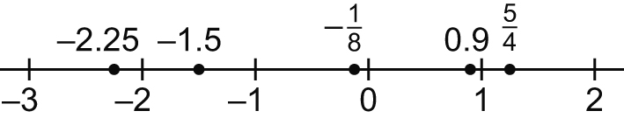3. A: –1, B: , C: 

4.

, 0.9, , –1.5, –2.25

5. a) –7.2 is greater because it is to the right  
 of –7.3 on a number line.

b)  is greater because it is greater than 1 whereas is less than 1.

c) 1.2 is greater since it is positive.

d) One-eleventh is greater than one-thirteenth. So, is closer to 0 than  on a number line. Since both numbers are negative, the number closer to 0, or farther to the right, is greater. So,  is greater.

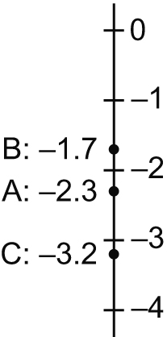6. a)

b) Diver C because she is farthest from 0 on the number line