**Grade 9 Math Exam Review Answer Key 2016**

**Part 1 – Circle Geometry G-1**

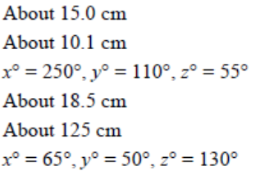

1.   
2.   
3.   
4.   
5.   
6.

**Part**

**Part 2 – Rational Numbers A-1 A-2**

|  |  |
| --- | --- |
|  |  |

**Part 3 – Powers B-1 B-2 B-3**

6.

|  |  |
| --- | --- |
| 7.  2.  1.    8.    4.  9.  3.    5. |  |

**Part 4 – Polynomials C-1 C-2 C-3**

1.

|  |  |
| --- | --- |
| 5.    6.  2.  7.    3.  4.    8. |  |

**Part 5 - Equations/Inequalities D-1 D-2**

6.

1.

|  |  |
| --- | --- |
| 7.  2.    8.  3.      4.      9.  5. |  |

**Part 6: Patterns & Lines E-1 E-2**

1.

|  |  |
| --- | --- |
| 6.    2.   1. v = -4t + 84   3.        8.    4.    1.  5.    2.  3.  4.  6.    7. | 6.            **Part 7 - Surface Area (F-3)**  a) 18 cm2  b) 22 cm2  c) 26 cm2   1. 515.48 m2 2. 253.28 m2   940.2 cm2  319 units squared |