**Test #4 Review 1 – Answer Key**

**Answer Section**

**MULTIPLE CHOICE**

1. 72

2. -5

3. -256

4. 10 000 000

5. -1

6. 88

7. 115 ÷ 95

8. ii and iii

9. -14.2

10. -14.9

**SHORT ANSWER**

13. ANS:

The answers for i and ii are positive.

14. ANS:





15. ANS:

|  |  |  |  |
| --- | --- | --- | --- |
| **Power** | **Base** | **Exponent** | **Repeated Multiplication** |
|  | 5 | 3 |  |
|  | 3 | 4 |  |
|  | 7 | 3 |  |
|  | 6 | 5 |  |

16. ANS:

10 000 000 = 107

17. ANS:



18. ANS:



19. ANS:

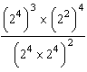 = 

20. ANS:

1.5

21. ANS:



22. ANS:



**PROBLEM**

23. ANS:

a) Replace  with a “” sign.

b) Replace  with a “+” sign.

c)  is always negative.

d) Replace  with a “” sign.

Not all products can be made positive.

In part c, there is an even number of factors in the power .

 is always positive, which means  is always negative.

24. ANS:

Each person is to be given 10 L of safe drinking water.

1 billion 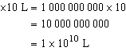



The amount of water required is about , or 10 000 000 000 L.

25. ANS:



26. ANS:

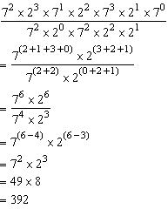

27. ANS:

Errors:

In line 1, the exponents of 3 should be added instead of multiplied.

In line 3, the exponents of 3 should be multiplied instead of added.

Correction:

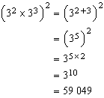

28. ANS:

