Test #2 Review Answer Key

Answer Section

MULTIPLE CHOICE

1. ANS: C

2. ANS: C

3. ANS: D

4. ANS: A

SHORT ANSWER

5. ANS:
49, 64, 81

6. ANS:
3 and 4

7. ANS:
No, because .

KEY: Conceptual Understanding | Communication

8. ANS:
18.6 cm

9. ANS:
7.8 m

10.

PROBLEM

11. ANS:
9.5 km

12. ANS:
Methods may vary. Sample:
ΔABD is a right triangle.
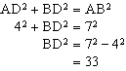
ΔBCD is a right triangle.
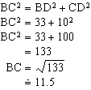
The length of BC is about 11.5 cm.

