Extra Practice 1

Target A-1

|  |
| --- |
| Lesson 1.1: Square Numbers and Area Models  1. Find the area of a square with each side length.  a) 7 units b) 11 units  2. Show that 16 is a square number.  Use a diagram, symbols, and words.  3. Which of these numbers is a perfect square? How do you know?  a) 14 b) 60 c) 36  4. These numbers are not square numbers.  Which two consecutive square numbers is each number between?  a) 7 b) 30 c) 50 d) 90  5. I am a two-digit square number. The sum of my digits is 13.  What square number am I?  6. A square patio has area 225 m2.  a) Find the dimensions of the patio.  b) The owner wants to put lights around the patio.  How many metres of lighting is needed?  c) Each string of lights is 25 m long.  How many strings of lights are needed? |

**Extra Practice 1 Answers**

**1. a)** 49 square units **b)** 121 square units

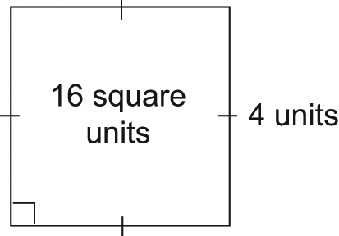**2.**

16 = 4 × 4.   
A square with area 16 square units has side length   
4 units.

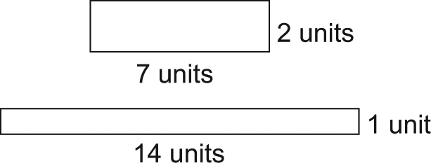**3. a)** Not a square. The rectangles with area   
14 square units are:

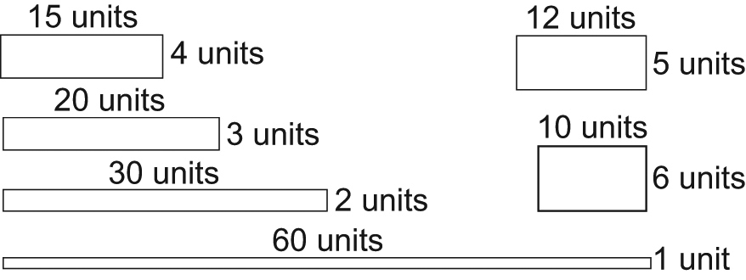**b)** Not a square. The rectangles with area 60 square units are:

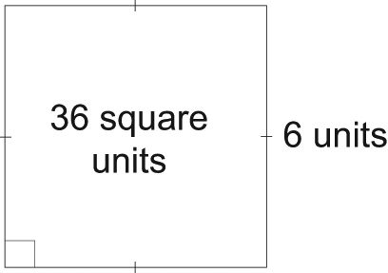**c)** A square. I can draw a square with side length   
6 units whose area is 36 square units.

**4. a)** 4 and 9 **b)** 25 and 36

**c)** 49 and 64 **d)** 81 and 100

**5.** 49

**6. a)** 15 m by 15 m

**b)** 60 m

**c)** 3 strings

Extra Practice 2

|  |
| --- |
| Lesson 1.2: Squares and Square Roots  Target A-1  1. Find.  a) 62 b) 112 c) 52  2. Find a square root of each number.  a) 49 b) 64 c) 196  3. a) List the factors of each number in ascending order.  Which numbers are squares? How do you know?  i) 70 ii) 144 iii) 180  b) Find a square root of each square number in part a.  4. The factors of each number are listed in ascending order.  Which numbers are square numbers?  Find a square root of each square number.  a) 216: 1, 2, 3, 4, 6, 8, 9, 12, 18, 24, 27, 36, 54, 72, 108, 216  b) 196: 1, 2, 4, 7, 14, 28, 49, 98, 196  c) 441: 1, 3, 9, 21, 49, 147, 441  5. Find a number whose square root is 24.  6. Find the square root of each number.  a) 122 b) 152 c) 372  7. Find the square of each number.  a)  b)  c) |

**Extra Practice 2 Answers**

**1. a)** 36 **b)** 121 **c)** 25

**2. a)** 7 **b)** 8 **c)** 14

**3. a) i)** 70: 1, 2, 5, 7, 10, 14, 35, 70  
Not a square since it has an even number of factors

**ii)** 144: 1, 2, 3, 4, 6, 8, 9, 12, 16, 18, 24, 36, 48, 72, 144  
This is a square since it has an odd number of factors.

**iii)** 180: 1, 2, 3, 4, 5, 6, 9, 10, 12, 15, 18, 20, 30, 36, 45, 60, 90, 180  
Not a square since it has an even number  
of factors

**b) ii)** 12

**4. a)** Not a square since it has an even number of factors

**b)** This is a square since it has an odd number of factors. The square root of 196 is 14.

**c)** This is a square since it has an odd number of factors. The square root of 441 is 21.

**5.** 576

**6. a)** 12 **b)** 15 **c)** 37

**7. a)** 9 **b)** 121 **c)** 841

Extra Practice 3

|  |
| --- |
| Lesson 1.3: Measuring Line Segments  Target A-1  1. Simplify.  a) 52 b) c) 82 d)  e) 12 f)  g) 92 h)  2. The area *A* of a square is given. Find its side length.  Which side lengths are whole numbers?  a) *A* = 9 cm2 b) *A* = 56 m2 c)*A* = 81 cm2  e) *A* = 16 m2 f)*A* = 42 cm2 g)*A* = 72 m2  3. Copy each square on grid paper. Find its area. Then write the side length of the square.  mmswncptg_08-01-BLM-22mmswncptg_08-01-BLM-21mmswncptg_08-01-BLM-20a) b) c)  4. Copy each line segment on grid paper. Draw a square on each line segment. Find the area of the square and the length of the line segment.  mmswncptg_08-01-BLM-26mmswncptg_08-01-BLM-23mmswncptg_08-01-BLM-24mmswncptg_08-01-BLM-25a) b) c) d) |

Extra Practice 3 Answers

**1.** **a)** 25**b)** 14

**c)** 64**d)** 15  
**e)** 1**f)** 7

**g)** 81**h)** 100

**2.** **a)** 3 cm**b)**  m **c)** 9 cm  
**d)** 4 m **e)**  cm **f)**  m  
The side lengths in parts a, c, and d are   
whole numbers.

**3.** **a)** 25 square units

**b)** 40 square units

**c)** 41 square units

**4.** **a)** 34 square units;  units

**b)** 65 square units;  units

**c)** 20 square units;  units

**d)** 61 square units;  units